Labsheet 6

Verilog design for 2x1 mux :

Verilog design for multiplexer:

module multiplexer (A, B, Sel, Out);

input A, B, Sel;

output Out;

wire tmp1, tmp0;

and (tmp1, B, Sel);

not (selbar, Sel);

and (tmp0, A, selbar);

or (out, tmp0, tmp1);

endmodule

logic for mux 2X1:

module mux21(  
input a,b,sel,  
output y);  
  
    assign y = sel ?b:a;  
  
endmodule

Test bench:

module tb_mux21;  
  
    reg A,B,SEL;  
    wire Y;  
      
    mux21 MUX (.a(A) ,.b(B),.sel(SEL),.y(Y));

    initial begin  
        A =1'b0;  
        B= 1'b0;  
        SEL =1'b0;  
        #45 $finish;  
    end  
      
    always #6 A =~A;  
    always #3 B =~B;  
    always #5 SEL = ~SEL;  
      
      
endmodule

Screenshot:

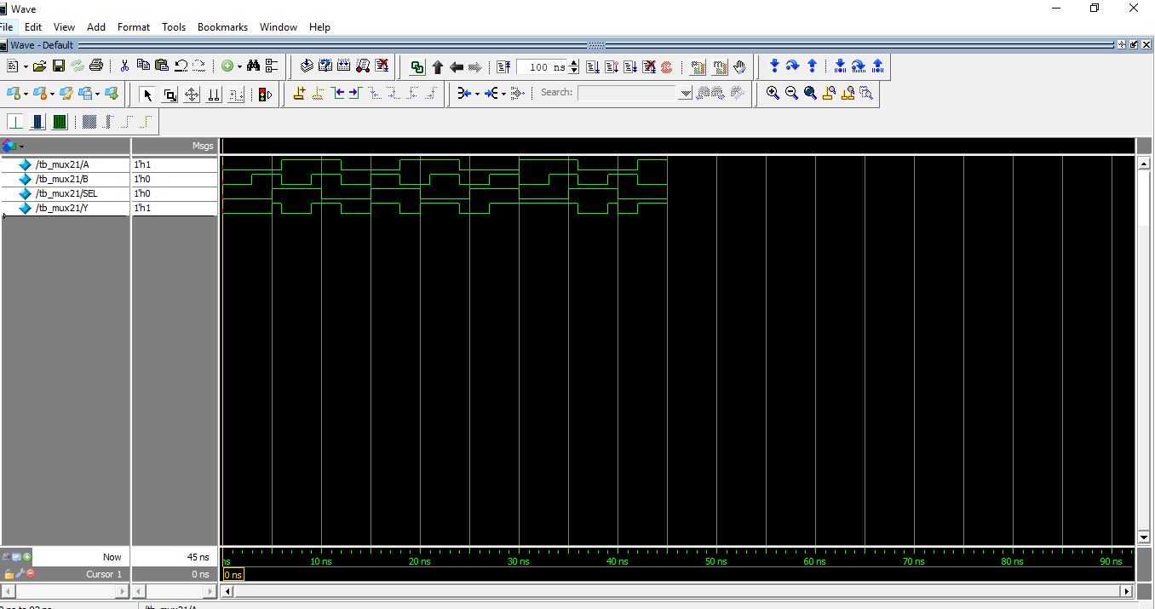

Logic for 4X1:

module mux41(

input i0,i1,i2,i3,sel0,sel1,

output reg y);

always @(*) //It includes all Inputs. You can use this instead of specifying all inputs in //sensivity list.Verilog-2001 Feature

begin

case ({sel0,sel1})

2'b00 : y = i0;

2'b01 : y = i1;

2'b10 : y = i2;

2'b11 : y = i3;

endcase

end

endmodule

Test Bench:

module tb_mux41;

reg I0,I1,I2,I3,SEL0,SEL1;

wire Y;

mux41 MUX (.i0(I0),.i1(I1),.i2(I2),.i3(I3),.sel0(SEL0),.sel1(SEL1),.y(Y));

initial begin

I0 =1'b0;

I1= 1'b0;

I2 =1'b0;

I3 =1'b0;

SEL0 =1'b0;

SEL1 =1'b0;

#45 $finish;

end

always #2 I0 = ~I0;

always #4 I1 =~I1;

always #6 I2 =~I1;

always #8 I3 =~I1;

always #3 SEL0 = ~SEL0;

always #5 SEL1 = ~SEL1;

endmodule

Screenshot:

